Task on docker-3
- Create a image from running container.
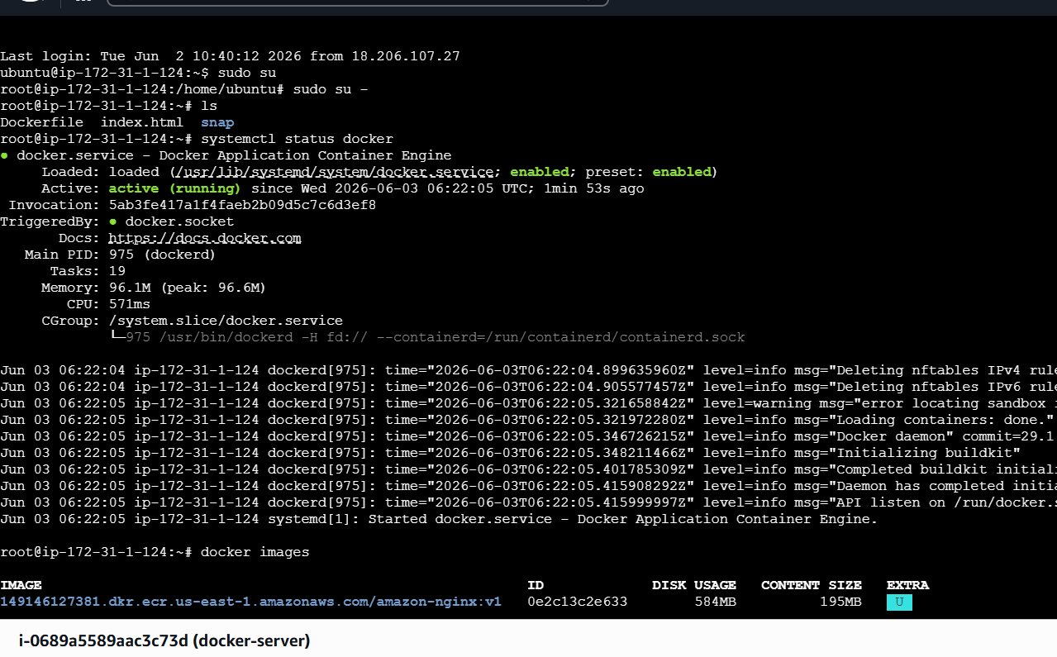
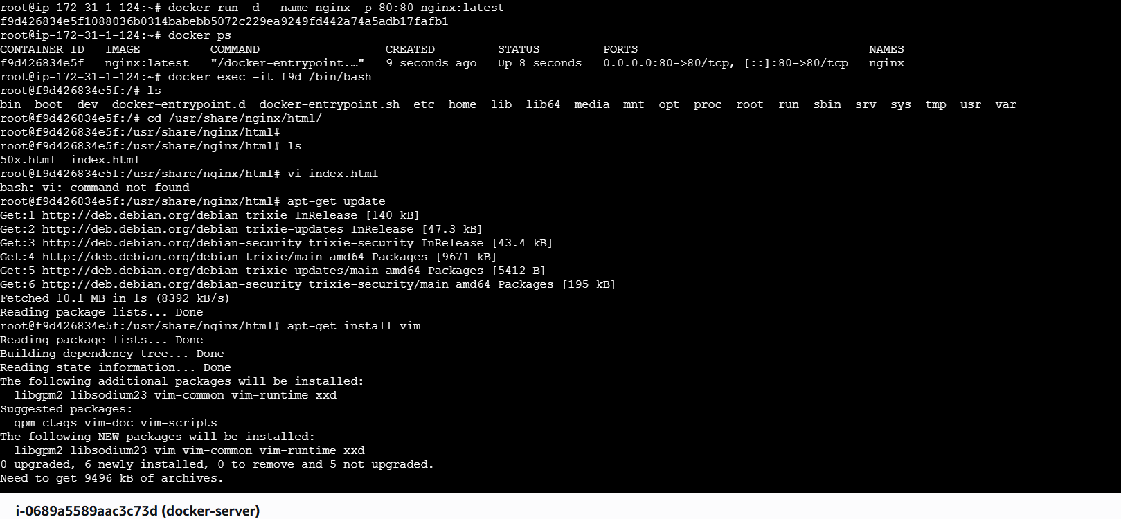
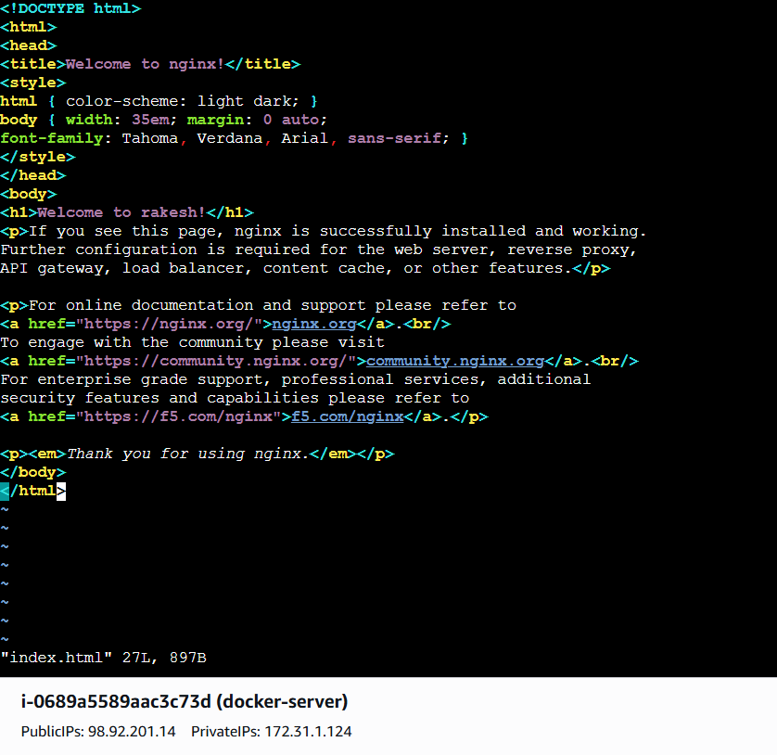
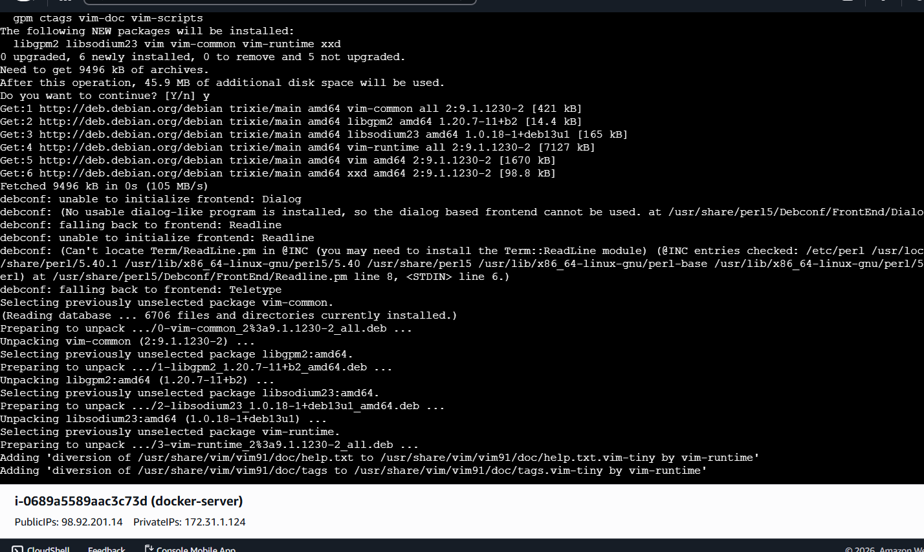
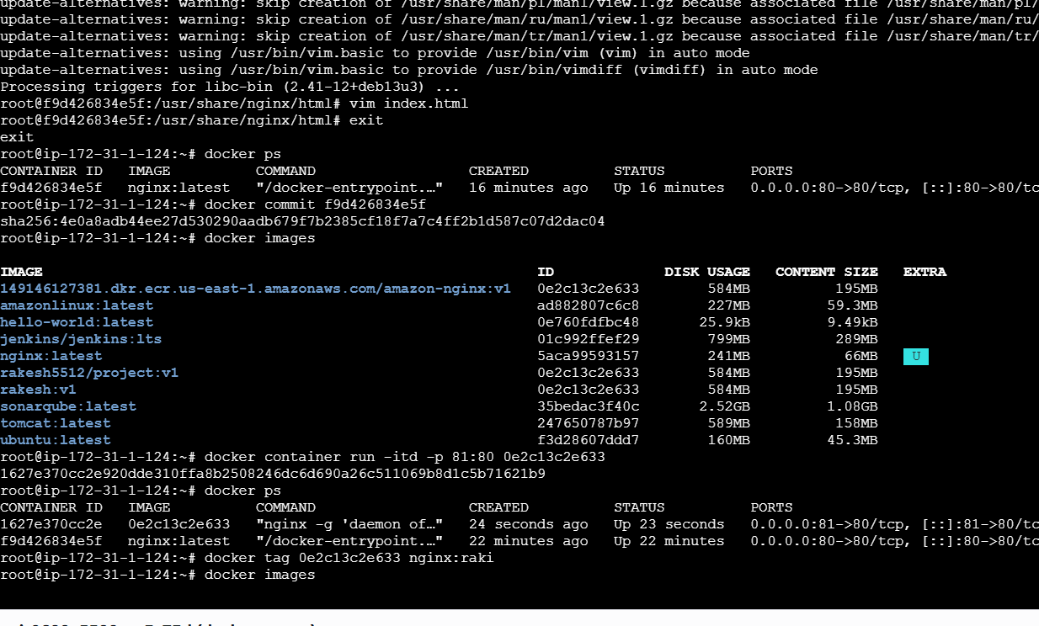
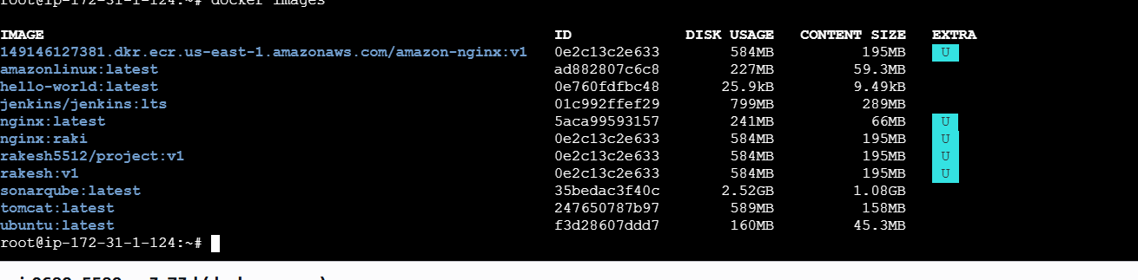

- Copy image from local machine to docker server and load the image.
For this first Install DOcker Desktop in our local machine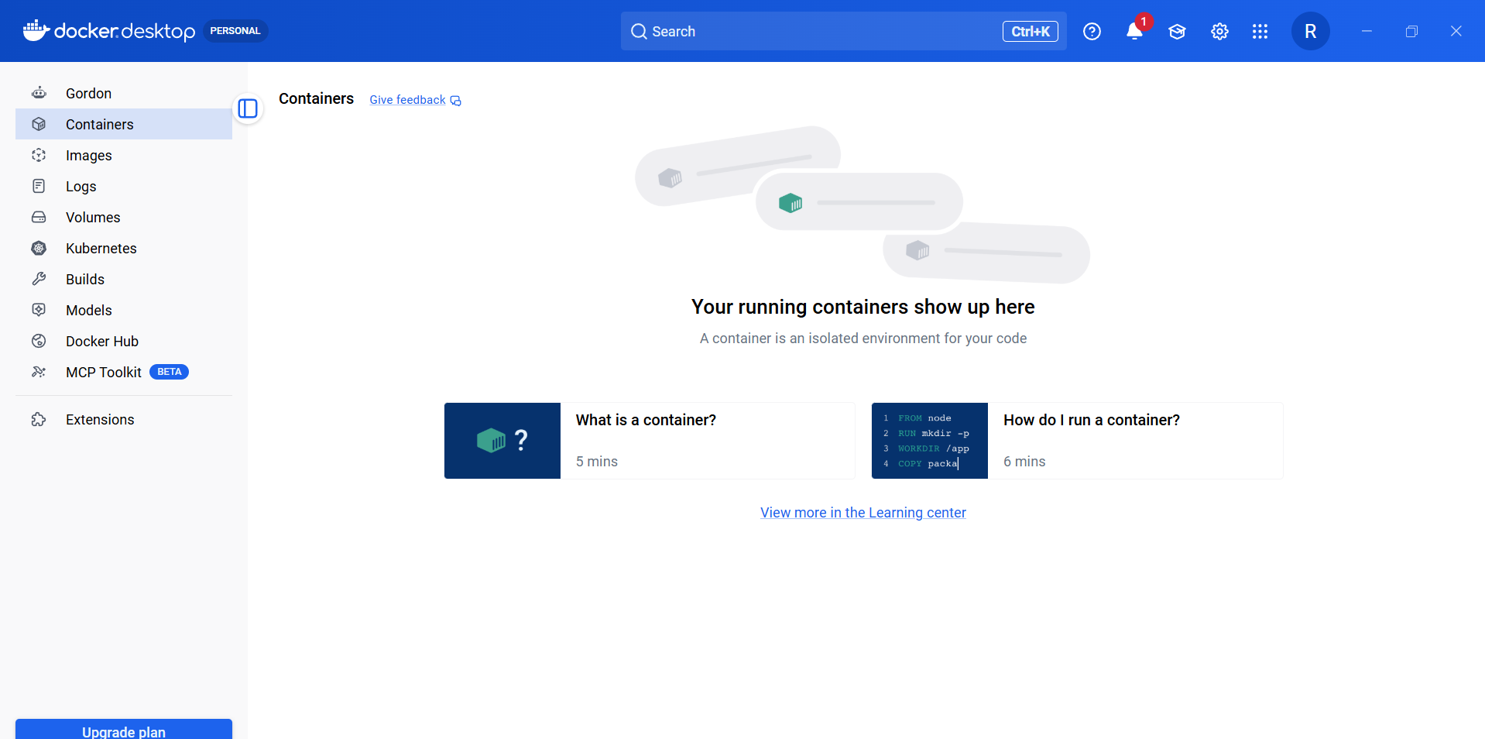

First save a image by giving name test.tar from image by using command
docker save -o test.tar nginx:raki
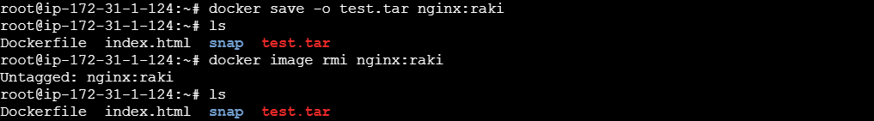
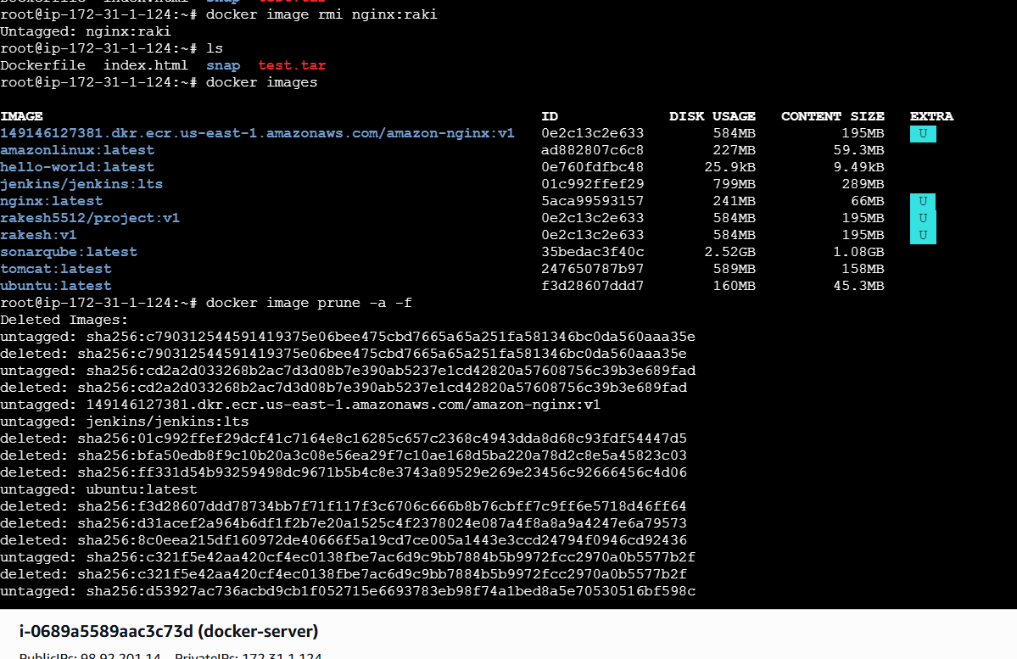
Now delete the all images using command
docker image prune -a -f
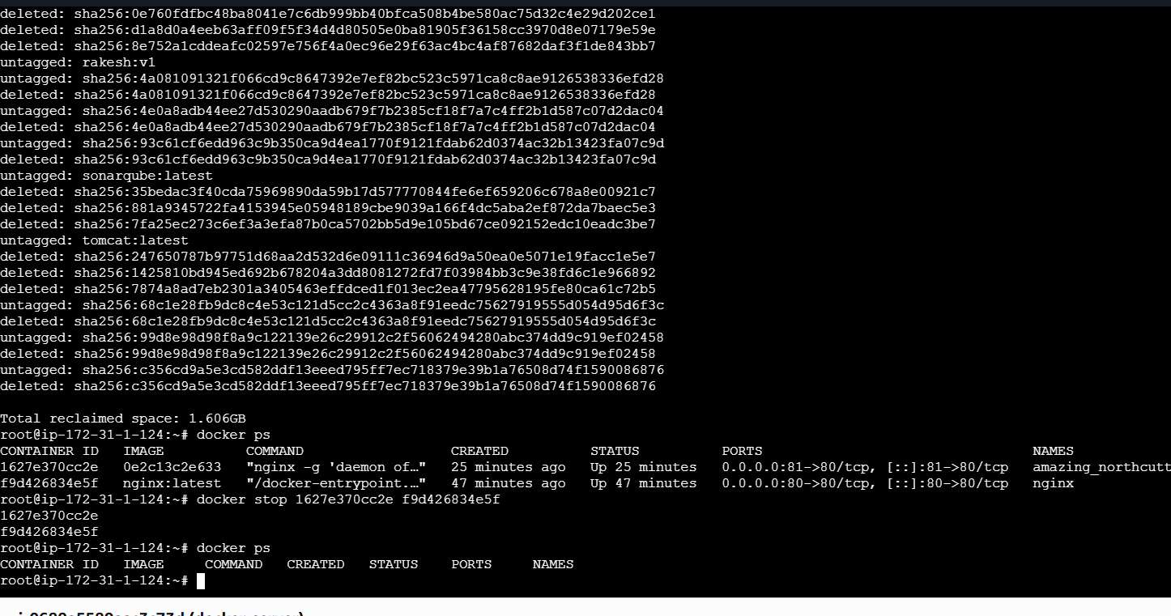now stop and delete all the containers by using below command
docker stop 1627e370cc2e f9d426834e5f
docker container prune -f
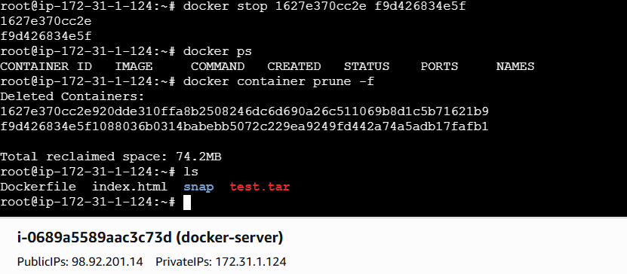
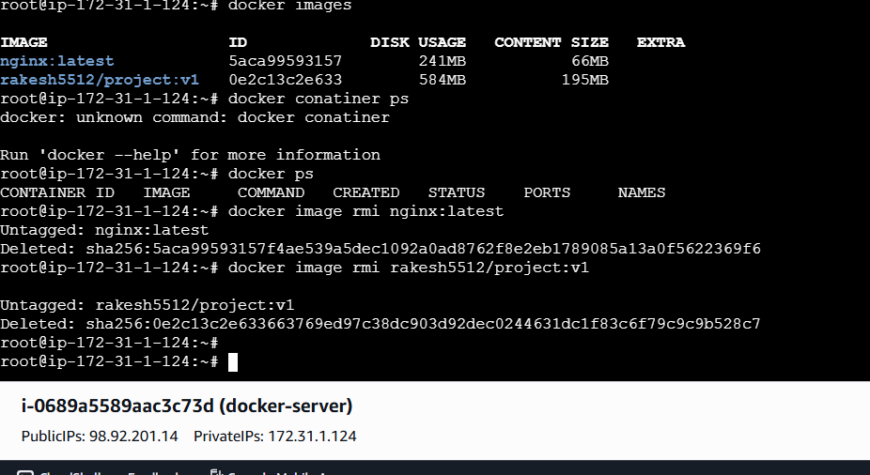
Now we don’t have any images and containers

Now check if docker has been installed or not by using
docker –version
Now lets pull an tomcat image on my local machine
Docker pull tomcat
As we cannot copy this image to our server we will be creating a tar file using command
Docker save -o tomcat.tar tomcat:latest
As we can see from above tar file is created now lets move the tar file to our server using command
scp -i /c/Users/RAKESH/Downloads/devops.pem tomcat.tar ubuntu@98.92.201.14:/tmp

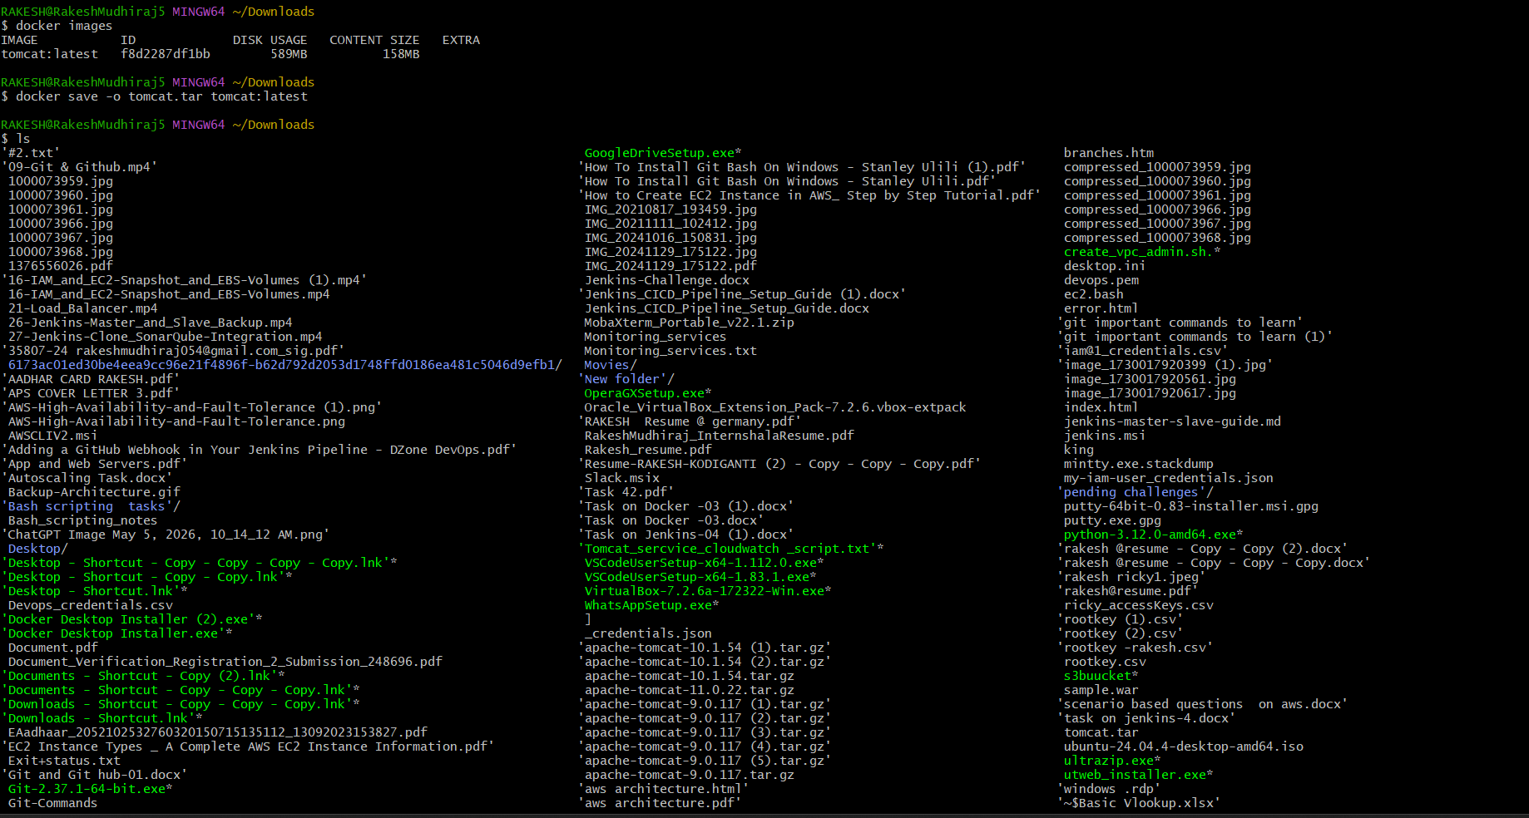
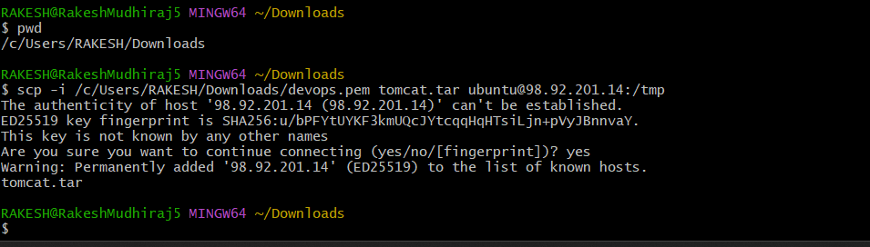
Copied successfully. Now lets check in our server if the file is existing or not
Cd /tmp ⇒checking the tmp folder has we have given this path

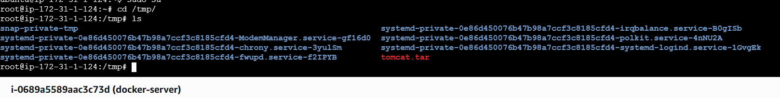
Now lets untar the file using command
Docker load -i tomcat.tar
Now lets run the new copies container using command
docker run -itd -p 8080:8080 tomcat:latest

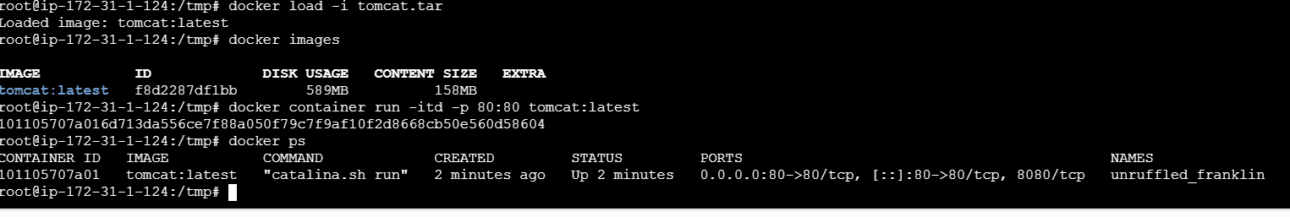
Docker Container has been created
- Create Docker image using alpine and customize with tomcat.
So lets first create a Dockerfile, Using command
- vi Dockerfile →FROM alpine:3.10
- MAINTAINER Techie_Horizon
- RUN mkdir /usr/local/tomcat/
- WORKDIR /usr/local/tomcat
- RUN apk --no-cache add curl && \
- apk add --update curl && \
- curl -O https://dlcdn.apache.org/tomcat/tomcat-9/v9.0.73/bin/apache-tomcat-9.0.73.tar.gz
- RUN tar -xvf apache*.tar.gz
- RUN mv apache-tomcat-9.0.73/* /usr/local/tomcat/.
- RUN rm -rf apache-*
- COPY sample.war /usr/local/tomcat/webapps
- RUN apk update && apk add openjdk8
  - WORKDIR /usr/local/tomcat
  - EXPOSE 8080
- CMD ["/usr/local/tomcat/bin/catalina.sh", "run"]
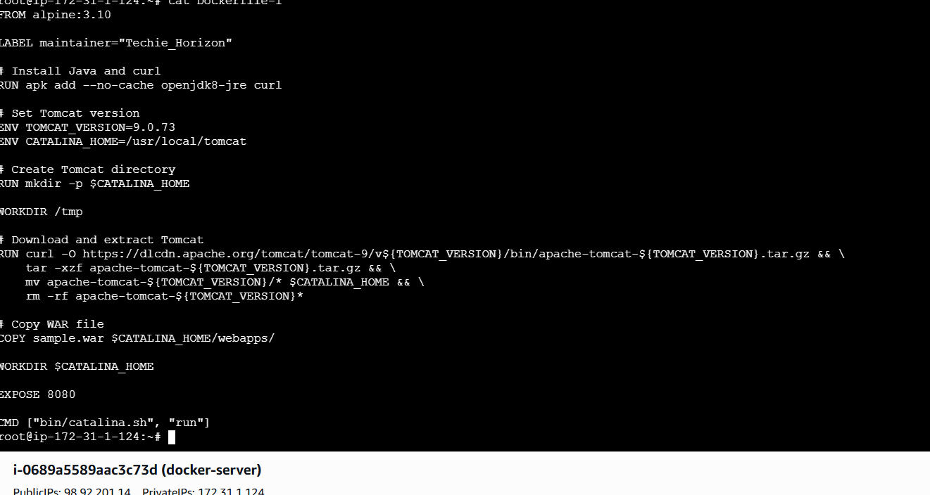
Now lets create the image from Docker file
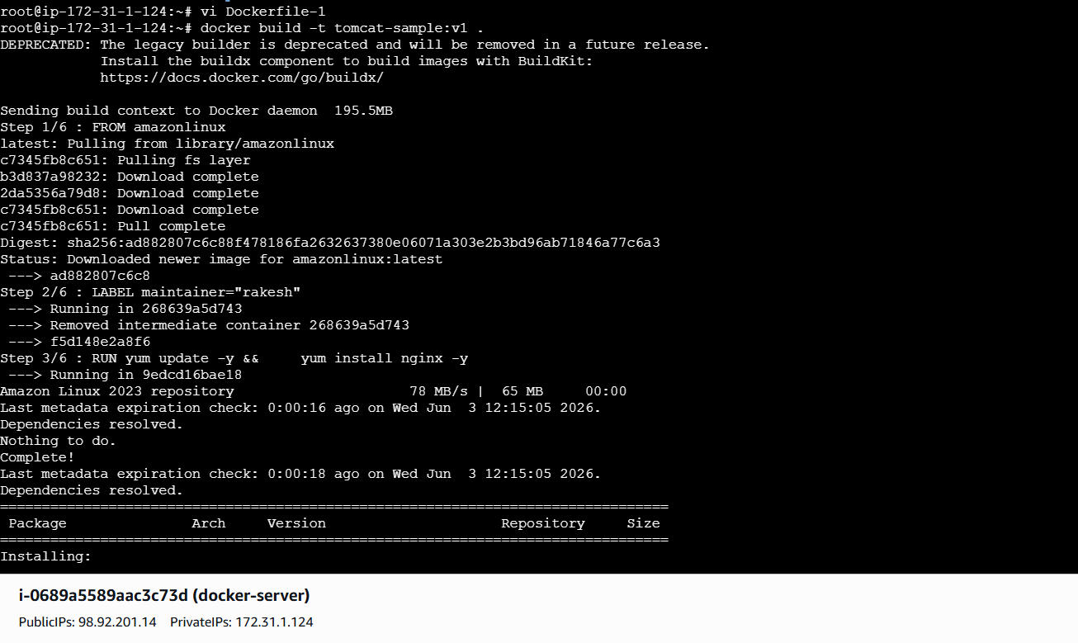
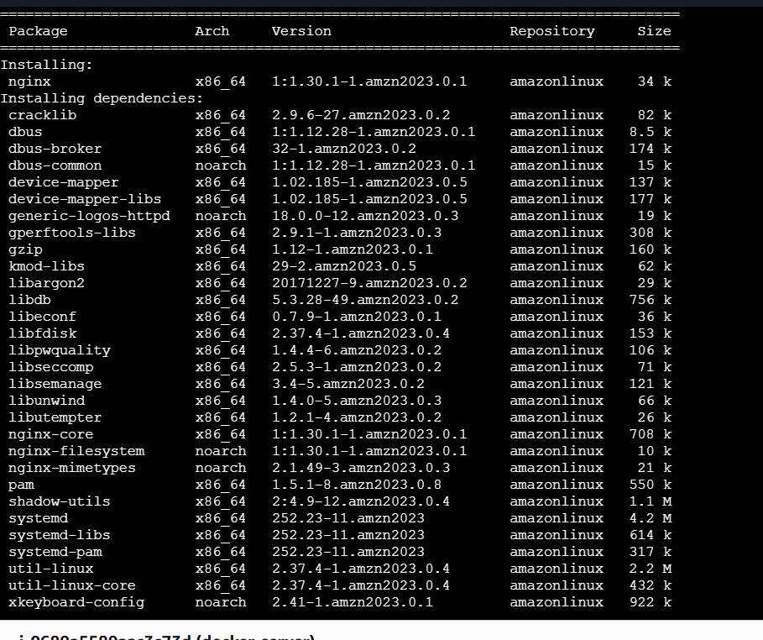
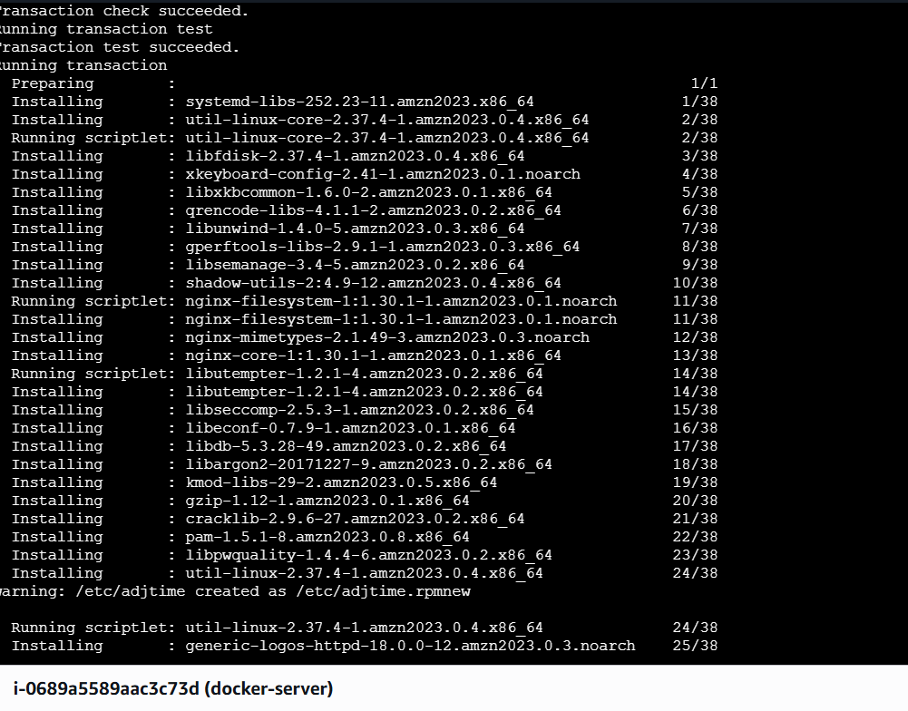
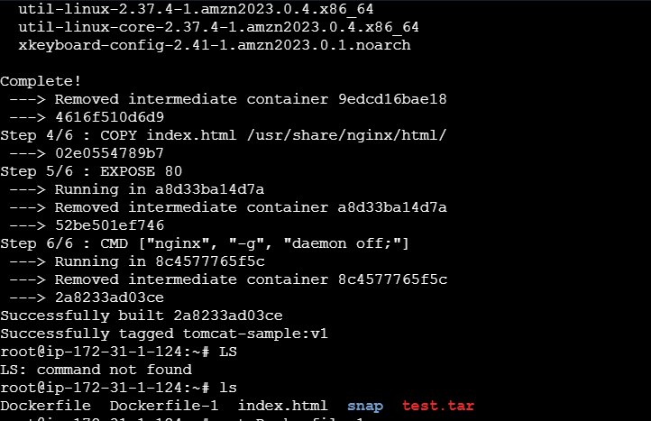
By using dockerfile a new image has been created
docker images
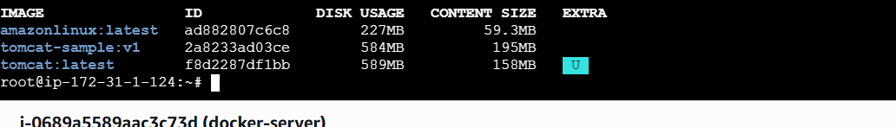
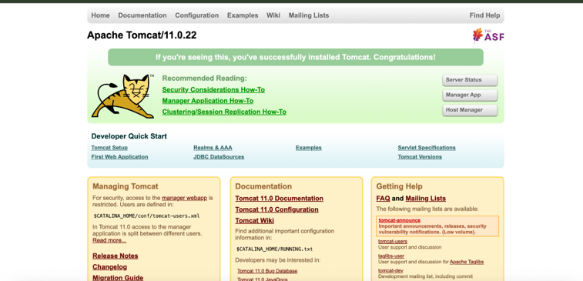

- Create single stage and multi stage docker file using this source code:https://github.com/betawins/multi-stage-example.git
Single Stage Docker File:
First lets clone or github repo in our machine
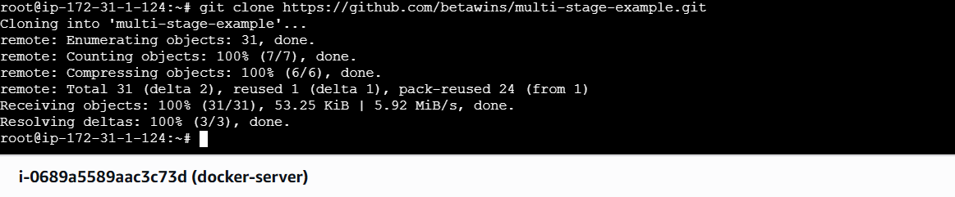
Once Its cloned do
ls⇒cd multi-stage-example⇒ls⇒vi Dockerfile⇒
FROM maven:3.8.5-openjdk-11
WORKDIR /app

COPY . .

RUN mvn clean package DskipTests

EXPOSE 8080

CMD ["java","-jar","target/*.jar"]
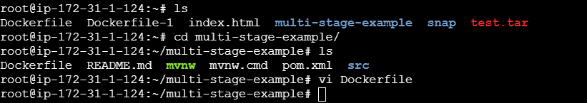
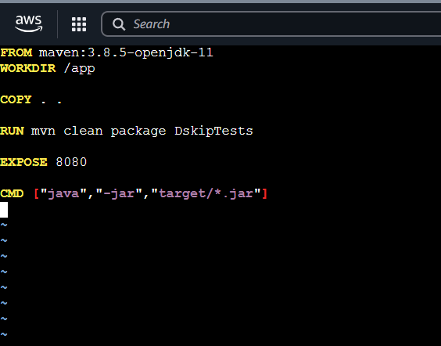
Here we will be just downloading maven image and it creates a new package

Lets build this now
Lets create an image using the Dockerfile’
docker build -t single-stage:v1 .
Now docker images
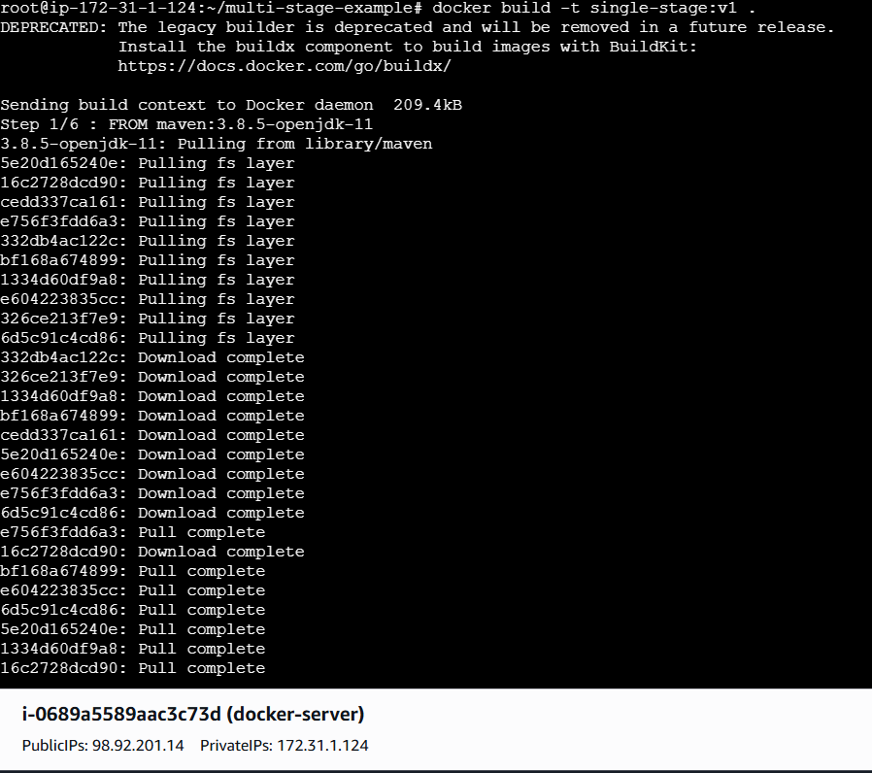
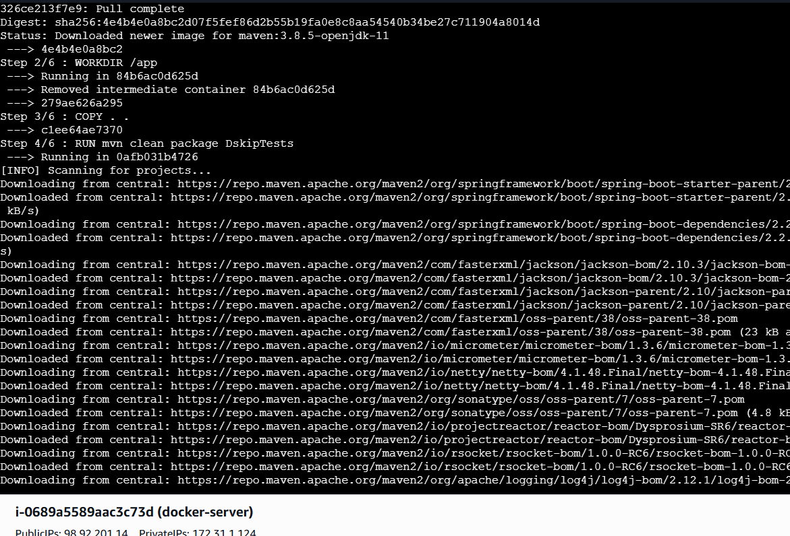

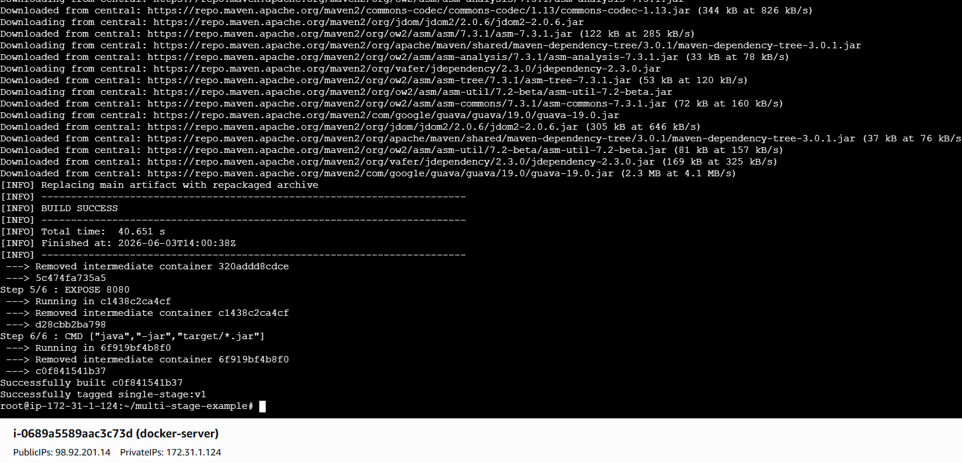
Now docker images
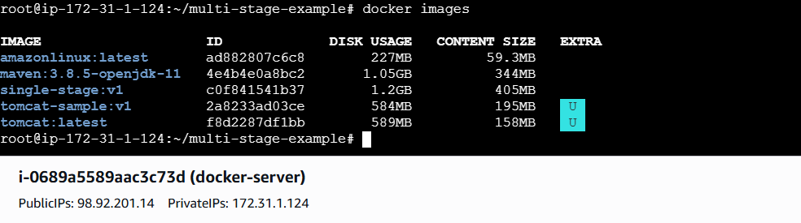
Now lets run the image
docker run -itd -p 8080:8080 –name spring-boot2 single-stage:v2
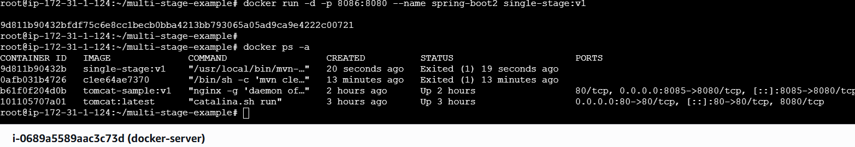
Lets check in the web page using public ip:8080
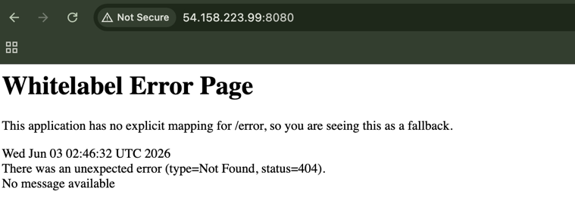
Multi-Stage Dockerfile
Lets create a Dockerfile
# Stage 1 - Build
FROM maven:3.8.5-openjdk-11 AS build

WORKDIR /app

COPY . .

RUN mvn clean package

# Stage 2 - Runtime
FROM eclipse-temurin:11-jre

WORKDIR /app

COPY --from=build /app/target/*.jar app.jar

EXPOSE 8080

CMD ["java","-jar","app.jar"]

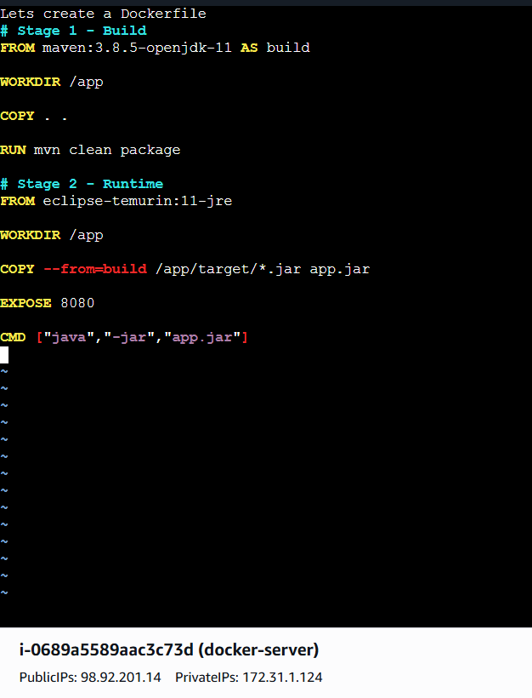
Lets Understand whats happing in the above Docker file:
This Dockerfile is using a multi-stage build to package and run a Java application efficiently. In the first stage (the build stage), it uses a Maven image with OpenJDK 11 to compile the application: it sets a working directory, copies the entire project into the container, and runs mvn clean package to generate a runnable JAR file. In the second stage (the runtime stage), it uses a much smaller Java Runtime Environment (JRE) image to keep the final container lightweight. It sets a working directory, copies only the built JAR file from the first stage into this new image, exposes port 8080 for the application, and finally runs the JAR using java -jar. This approach helps reduce the final image size and improves security by excluding build tools from the runtime environment.
Lets start the image
docker build -t mutistage:v2 .
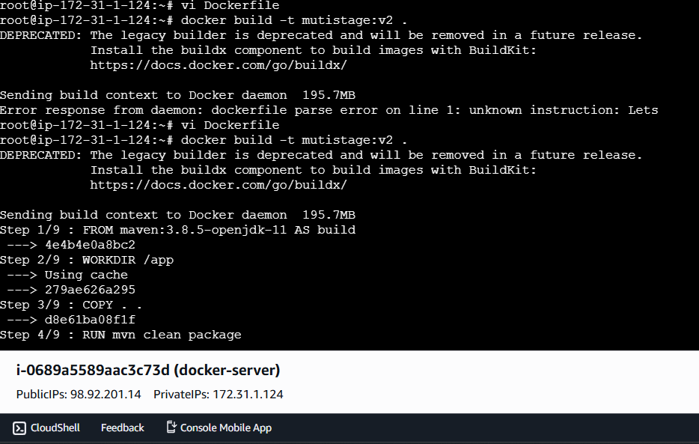
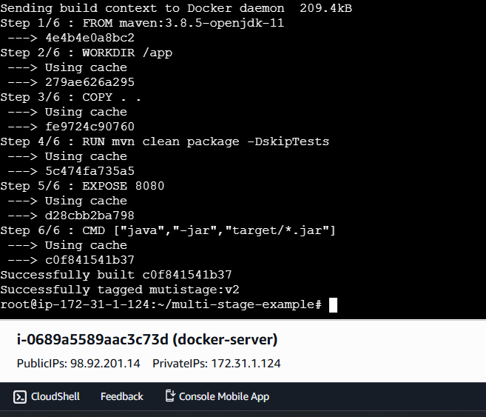

Build is Successfull
Now lets run the container using command
docker run -d -p 8083:8080 –name spring-boot2 mutistage:v2
Docker ps -a to check the running containers
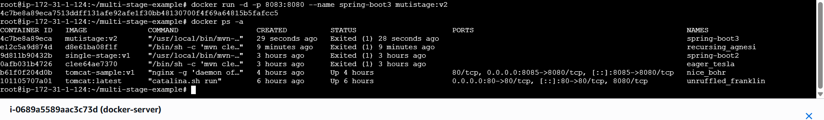
So container is successful created and running
Let's check in browser too
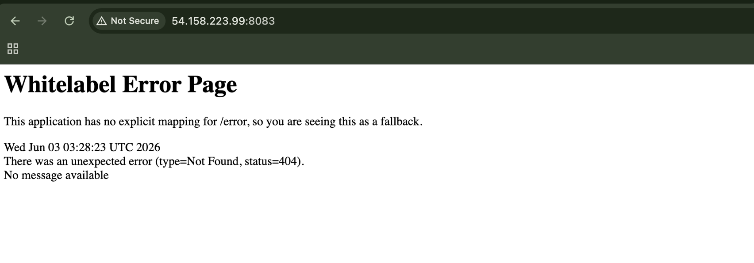
- Install docker compose and execute sample application.
Lets update the packages first
apt update
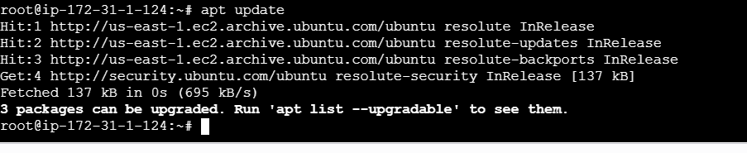
Lets install docker compose now
sudo curl -SL https://github.com/docker/compose/releases/latest/download/docker-compose-linux-x86_64 \
-o /usr/local/bin/docker-compose

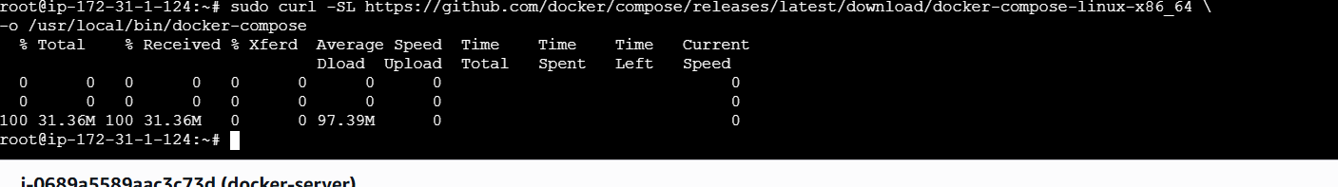
Now lets check the version of our docker-compose
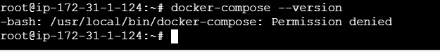
As its says we dont have permission lets give the permissions and check
sudo chmod +x /usr/local/bin/docker-compose and
also lets create sym link using the command
ln -s /usr/local/bin/docker-compose /usr/bin/docker-compose
And now lets check for version
Docker-compose –version
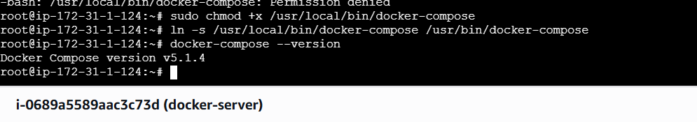
Lets execute a sample application now
Inside vi docker-compose.yml;
version: '3'

services:
web:
image: nginx
ports:
- "8080:80"

db:
image: mysql
environment:
MYSQL_ROOT_PASSWORD: root123
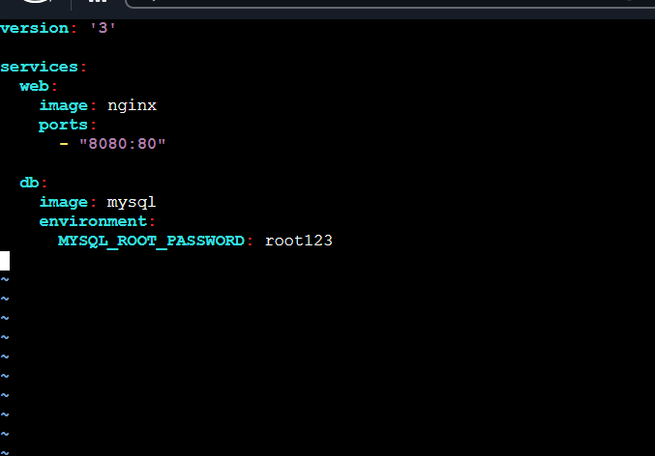
Now lets execute the compose file
docker-compose up -d
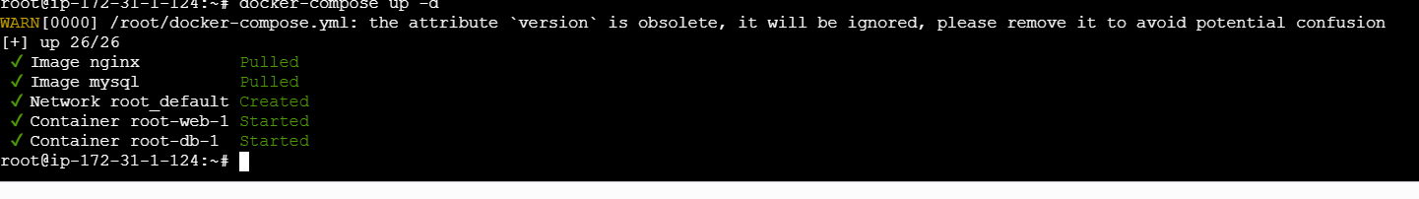

docker ps ⇒for checking the running containers
Lets check in browser using publicIP:8080
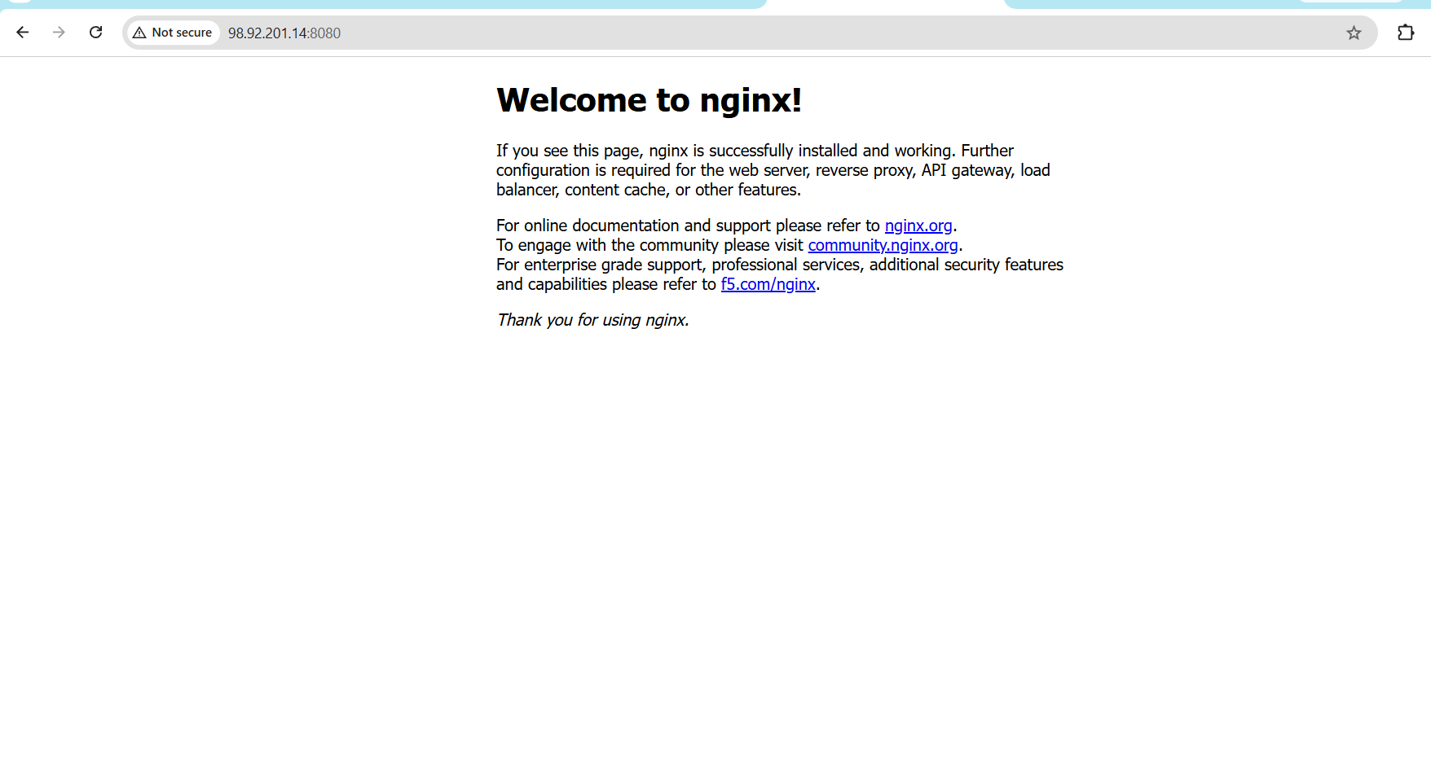

- Implement solution to scan images when pushed to docker registry.
First lets turn on the security option in our docker hub
Docker hub→repository→our repo→settings→Docker Scout image analysis→save
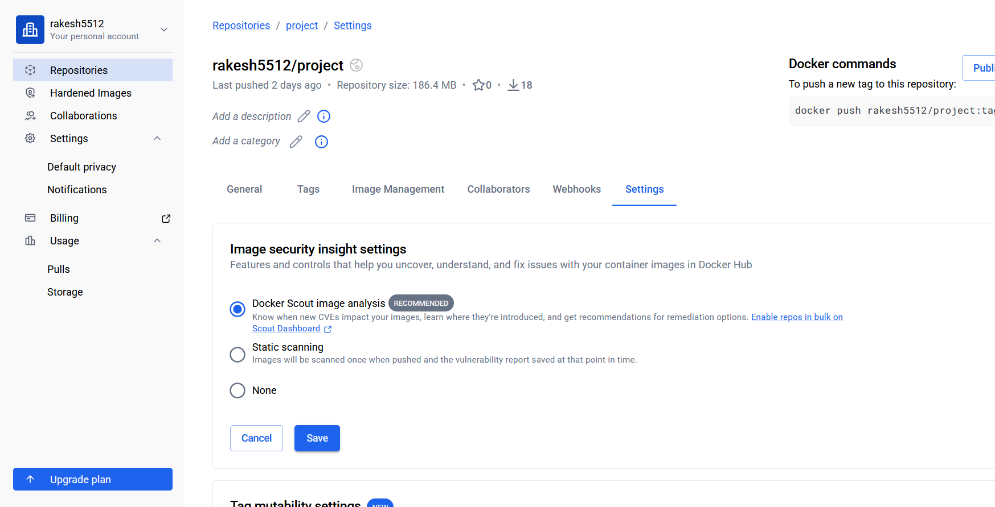
Now lets build an image from scratch and push the image to the hub and scan it
So I already have an image i will use the image and push the image to docker hub

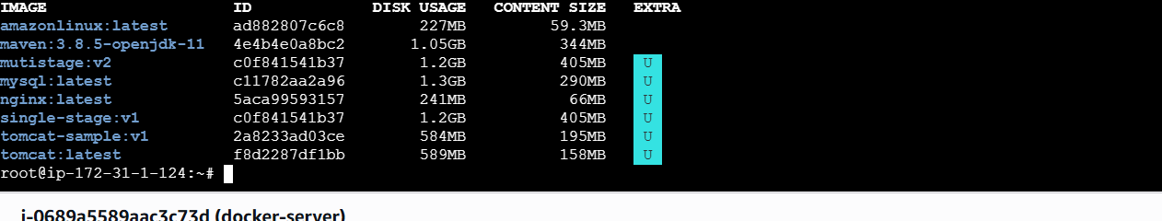
Docker login ⇒ once succeeded
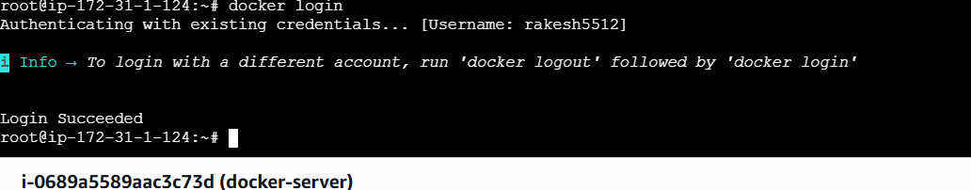
docker tag mutistage:v1 ricky/techie:v1
Docker images
docker push ricky/techie:v1
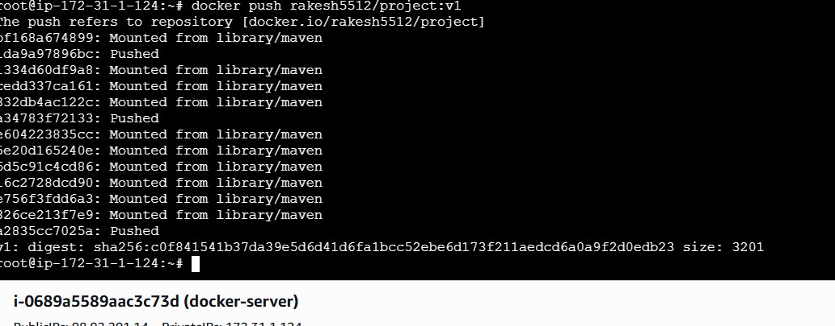
Lets check in the Docker Hub

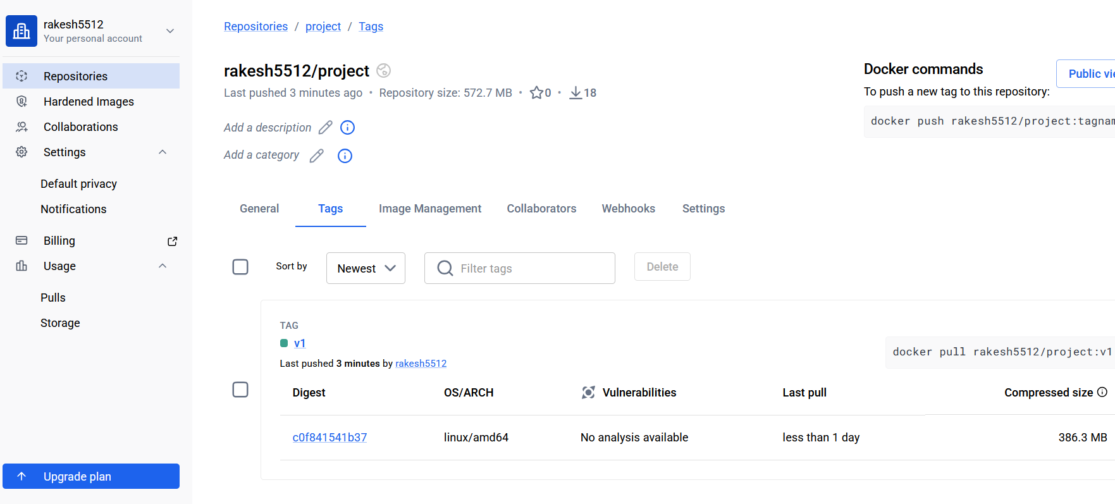
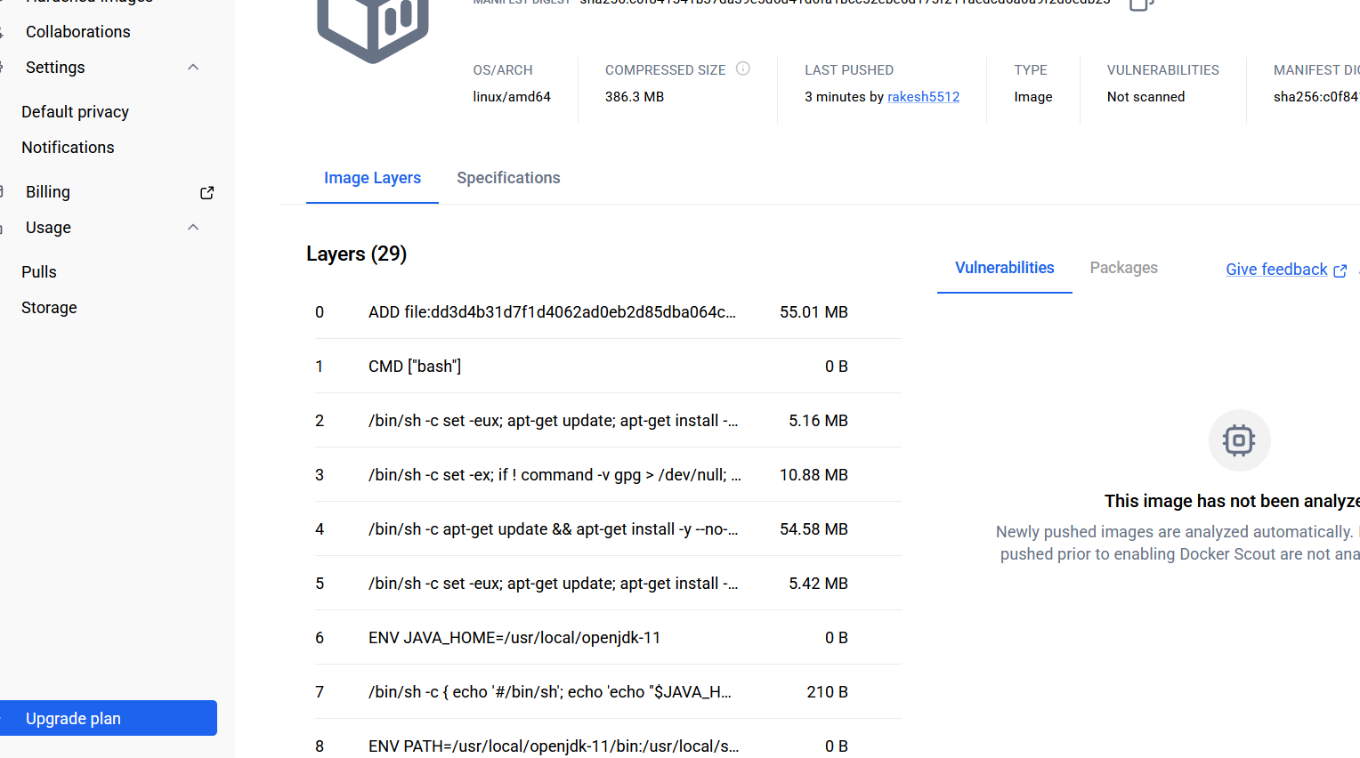
- Implement solution to scan images when pushed to AWS ECR.
Lets turn on the scan feature first
AWS ECR→repo→actions→repo scan filters→basic–save
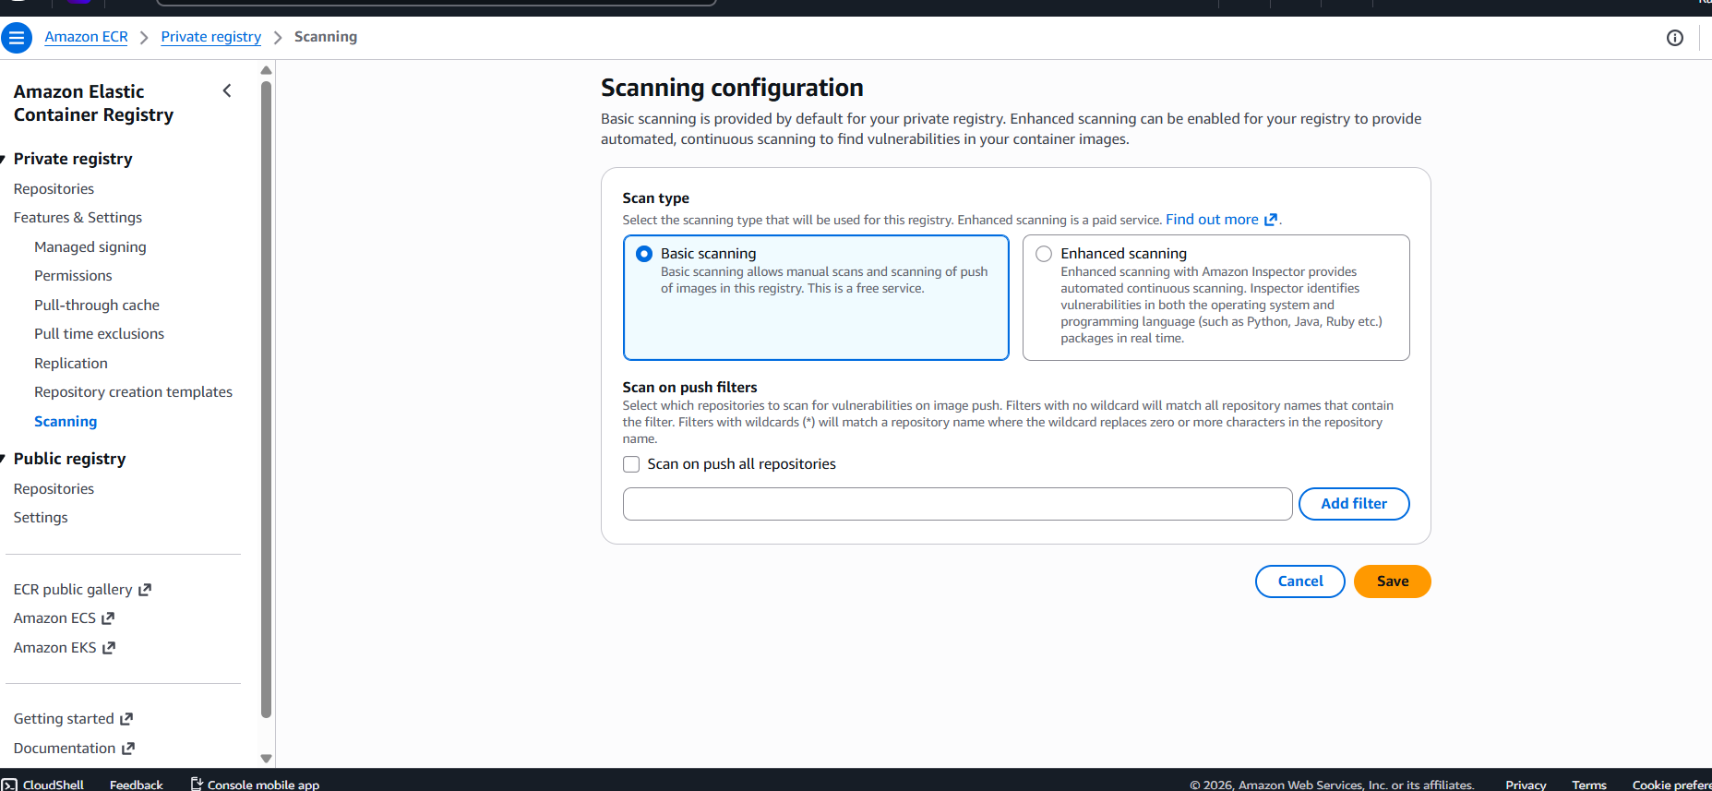
Now lets goto cli and login to ECR-AWS
aws ecr get-login-password --region us-east-1 | \
docker login --username AWS \
--password-stdin 926046660167.dkr.ecr.us-east-1.amazonaws.com
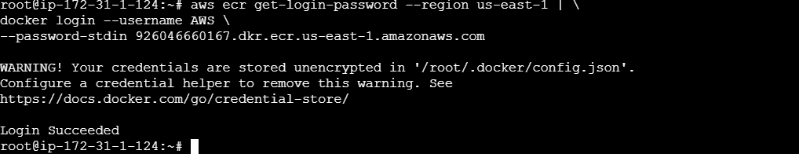
AWS ECR login ⇒ once succeeded
docker tag mutistage:v2 149146127381.dkr.ecr.us-east-1.amazonaws.com/amazon-nginx:v3
Docker images
docker push 149146127381.dkr.ecr.us-east-1.amazonaws.com/amazon-nginx:v3
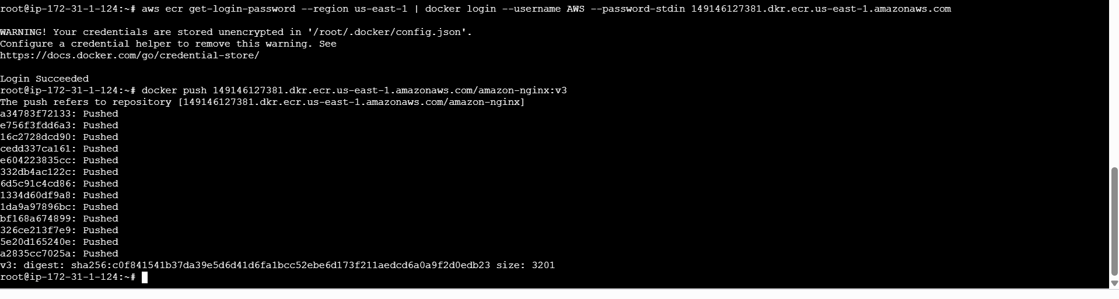
Now lets check in AWS-ECR
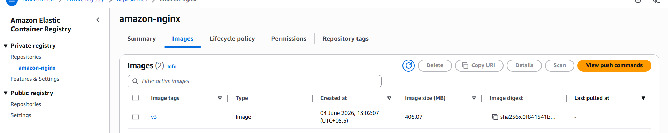

Now lets check if the scanning has been done or not
Its in process
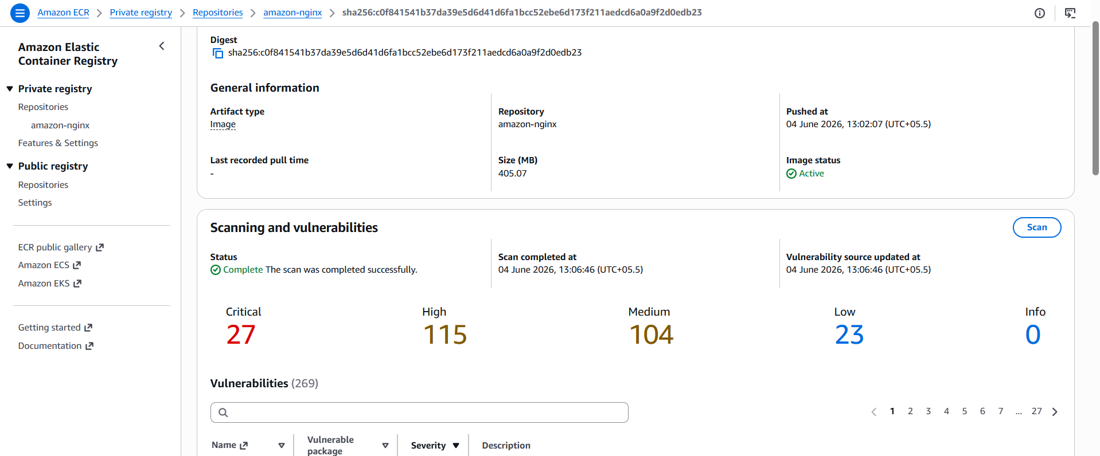

- Create a Jenkins pipeline to create a docker image and push the image to Docker hub.
So First Lets pull Jenkins
docker run -itd \
--name jenkins \
-p 8085:8080 \
-p 50000:50000 \
-v jenkins_home:/var/jenkins_home \
jenkins/jenkins:lts
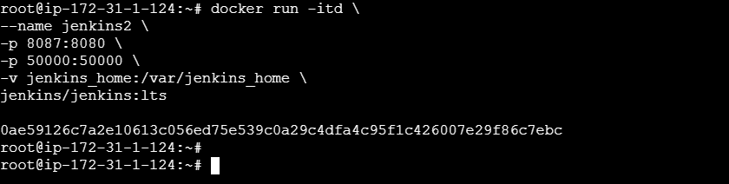
Lets Start jenkins
docker start Jenkins 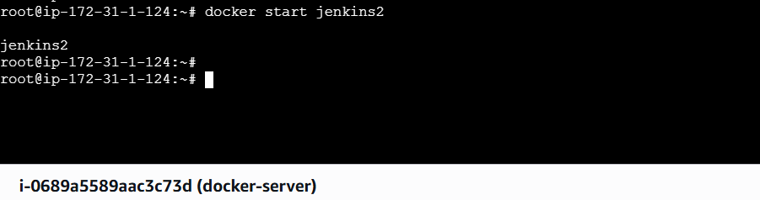
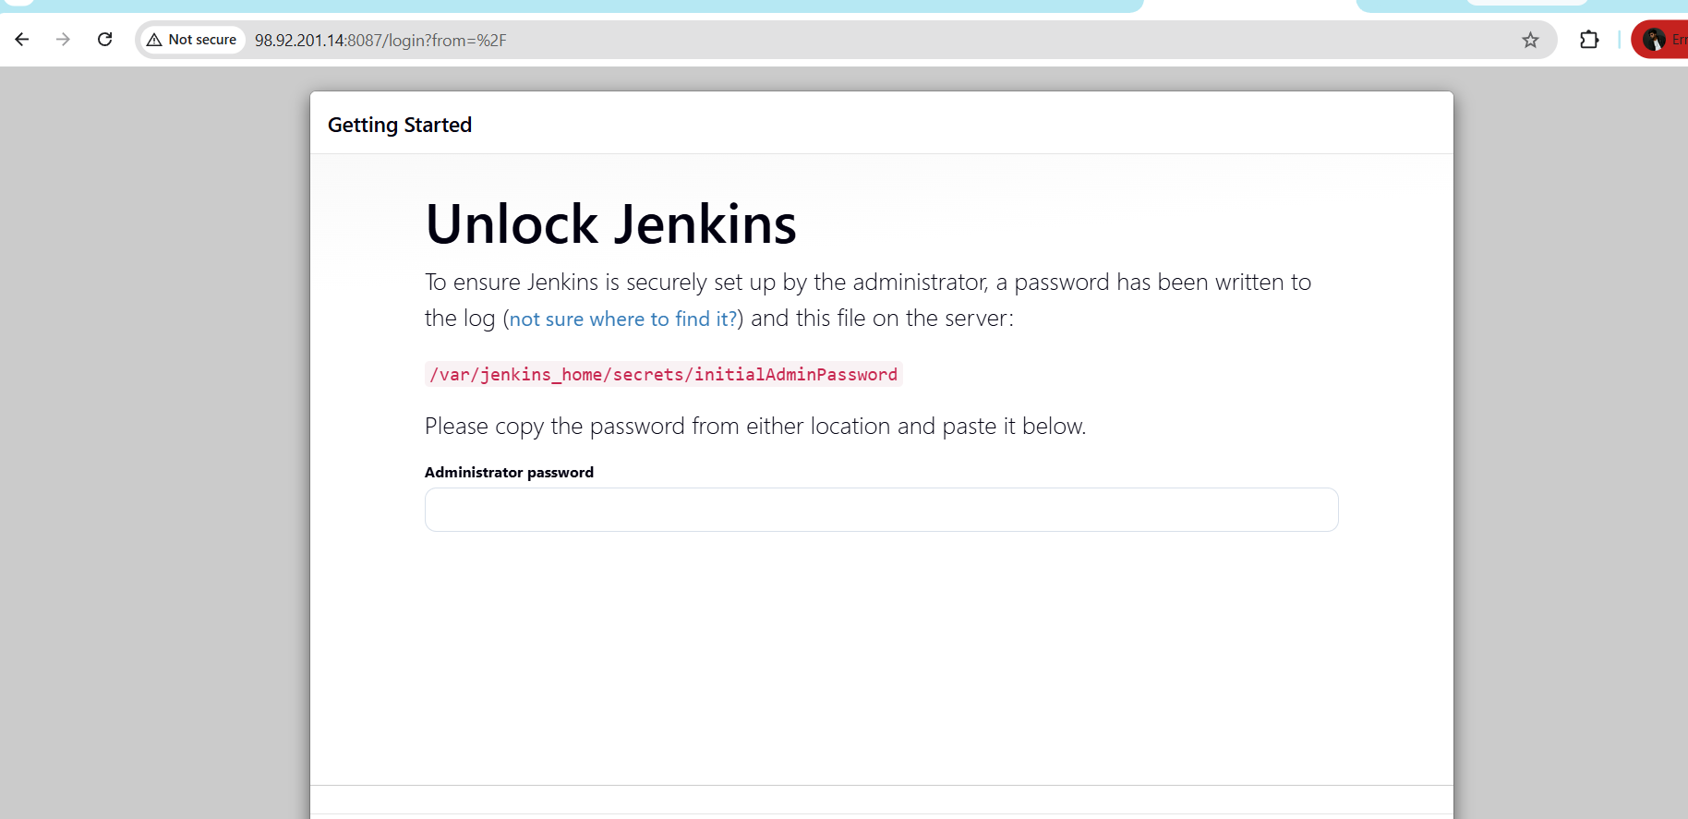
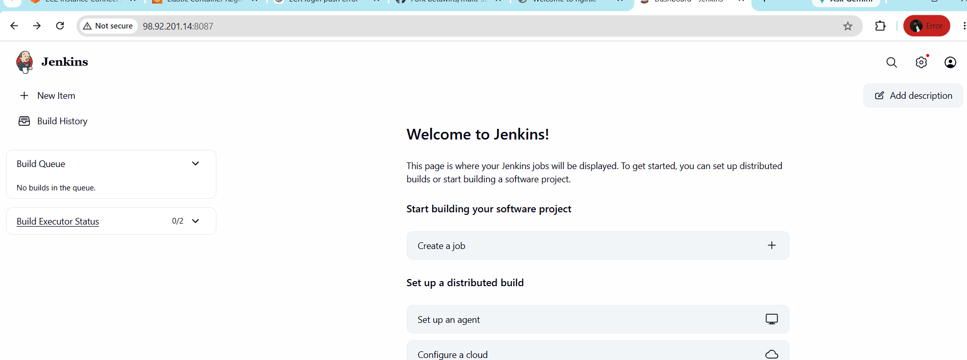
Lets create credentials for Dockerhub
Generate access token in Dockerhub
DockerHub→Settings→personal access tokens→permissions(RWX) →copy 2→give in manage jenkins
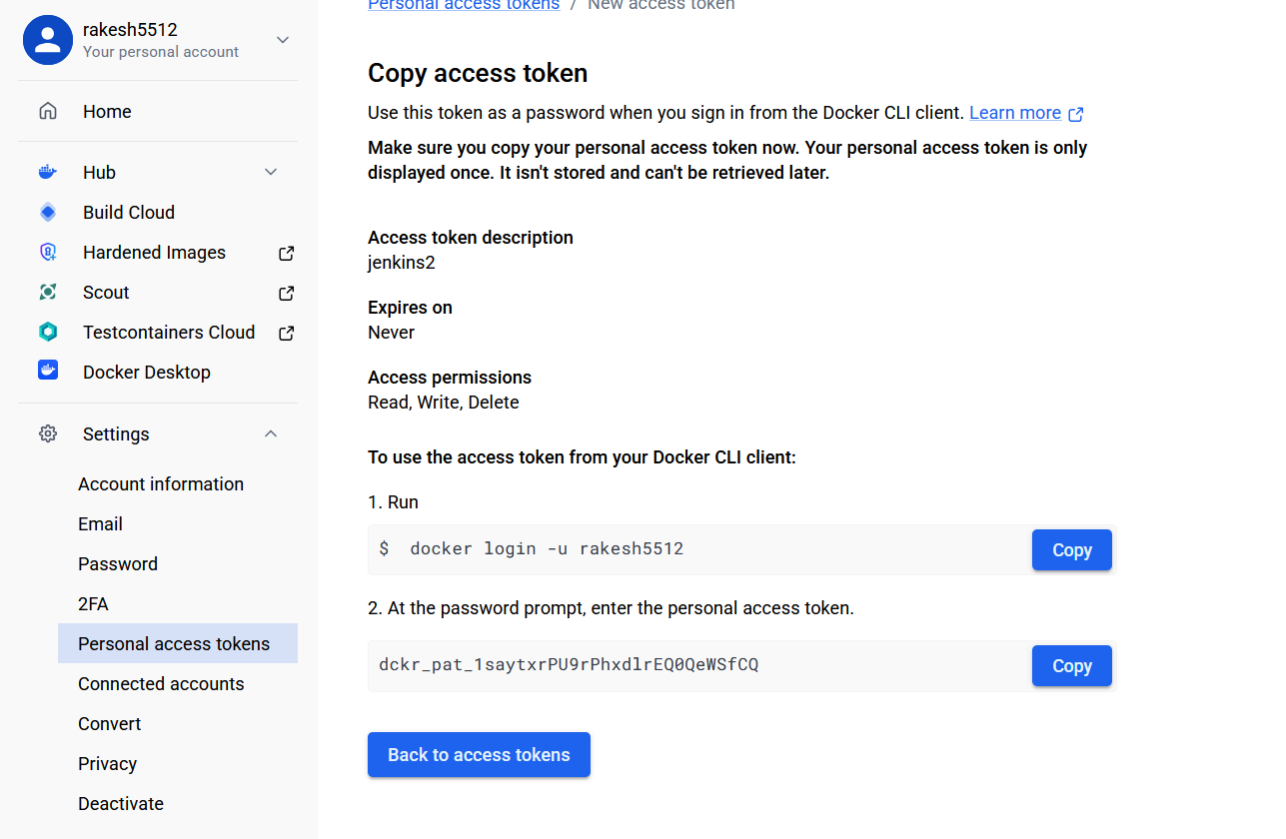
Manage jenkins→credentials→
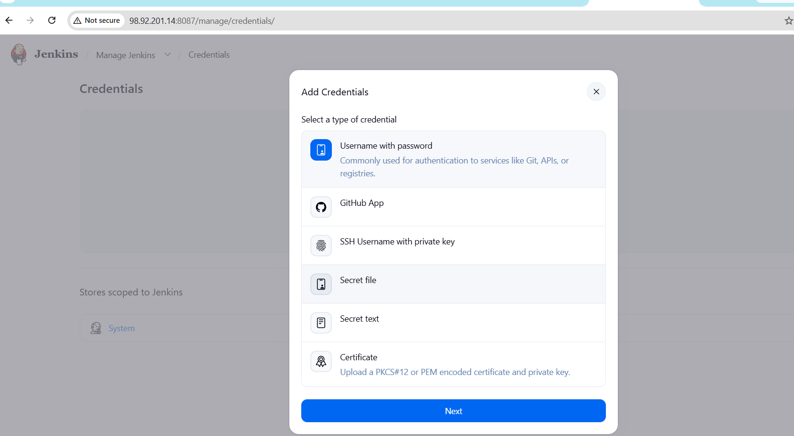
Use Dockerhub User name and password
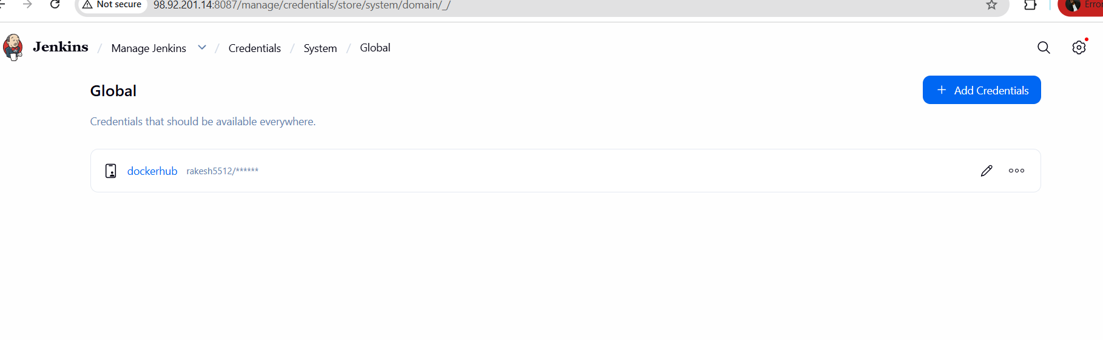
Lets fork the repo and change the Dockerfile, because its using the old versions of java
FROM maven:3.8.6-openjdk-8 AS builder

RUN mkdir -p /app/source

COPY . /app/source

WORKDIR /app/source

RUN mvn clean package

# Stage 2 - Runtime
FROM eclipse-temurin:8-jre

COPY --from=builder /app/source/target/*.jar /app/app.jar

EXPOSE 8080

ENTRYPOINT ["java","-Djava.security.egd=file:/dev/./urandom","-jar","/app/app.jar"]
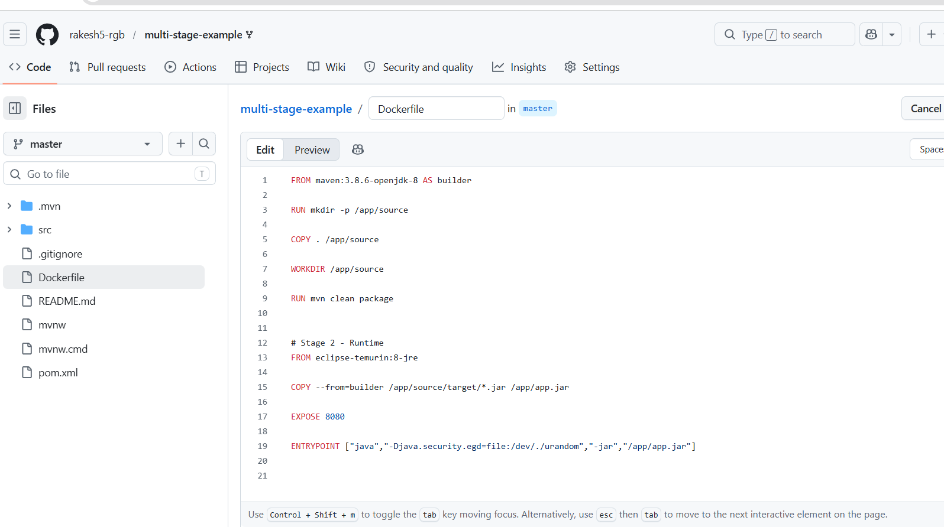
Lets Create new Job
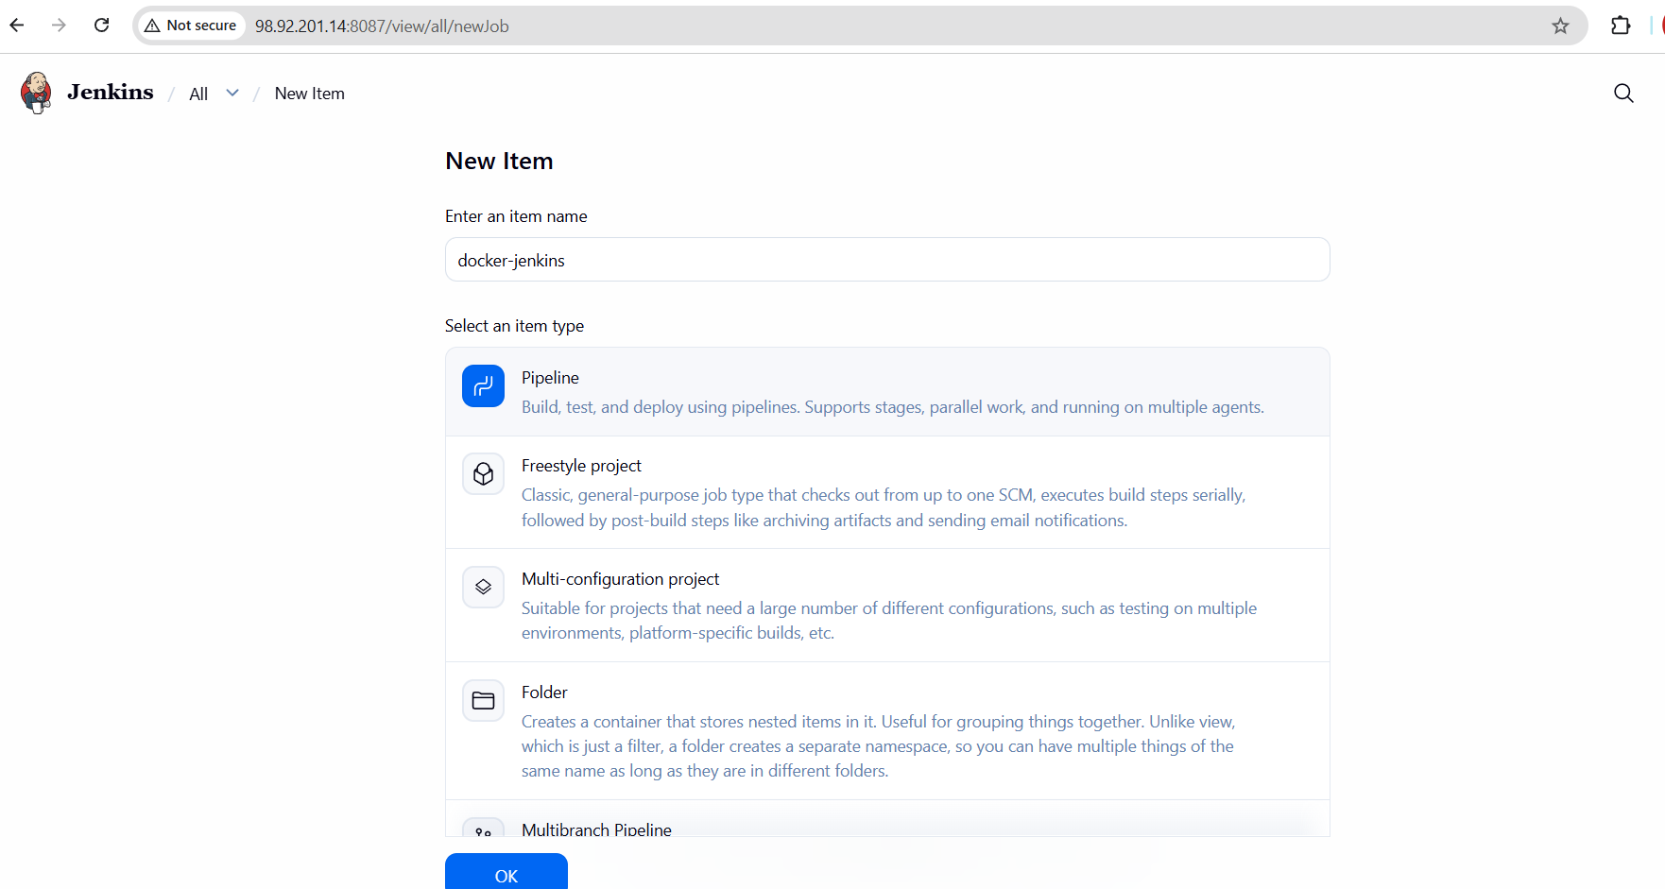
Add script
pipeline {
agent any

environment {
IMAGE_NAME = " rakesh5512/project"
IMAGE_TAG = "v1"
}

stages {

stage('Clone Code') {
steps {
git ' https://github.com/rakesh5-rgb/multi-stage-example.git'
}
}

stage('Build Docker Image') {
steps {
sh 'docker build -t $IMAGE_NAME:$IMAGE_TAG .'
}
}

stage('Login DockerHub') {
steps {
withCredentials([
usernamePassword(
credentialsId: 'dockerhub',
usernameVariable: 'DOCKER_USER',
passwordVariable: 'DOCKER_PASS'
)
]) {
sh '''
echo $DOCKER_PASS | docker login \
-u $DOCKER_USER \
--password-stdin
'''
}
}
}

stage('Push Image') {
steps {
sh 'docker push $IMAGE_NAME:$IMAGE_TAG'
}
}
}

post {
success {
echo 'Docker image pushed successfully!'
}

failure {
echo 'Pipeline failed!'
}
}
}
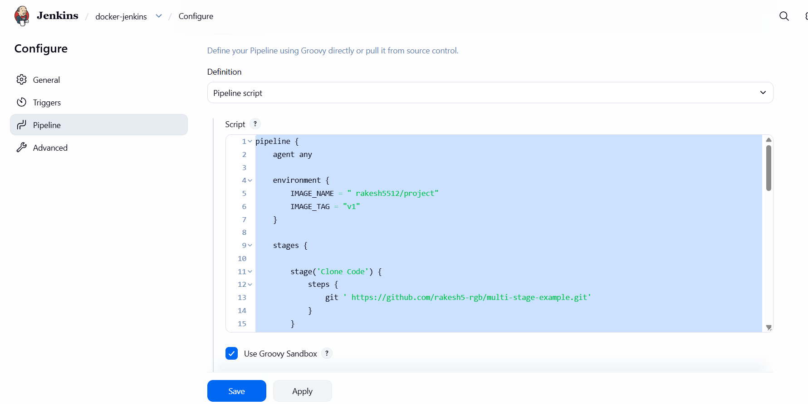
Build Scuucessfull
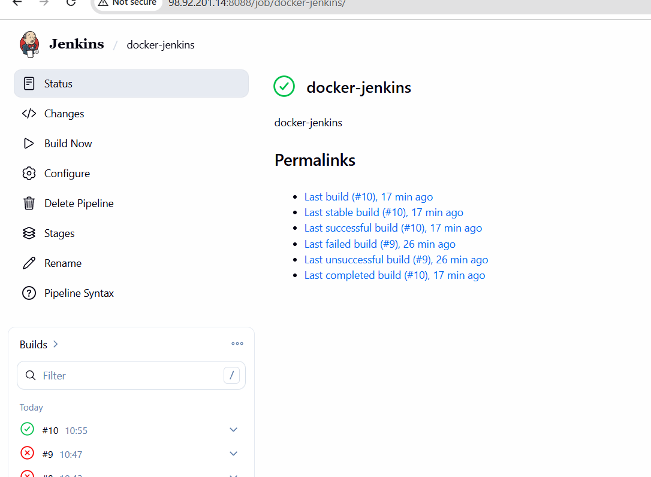
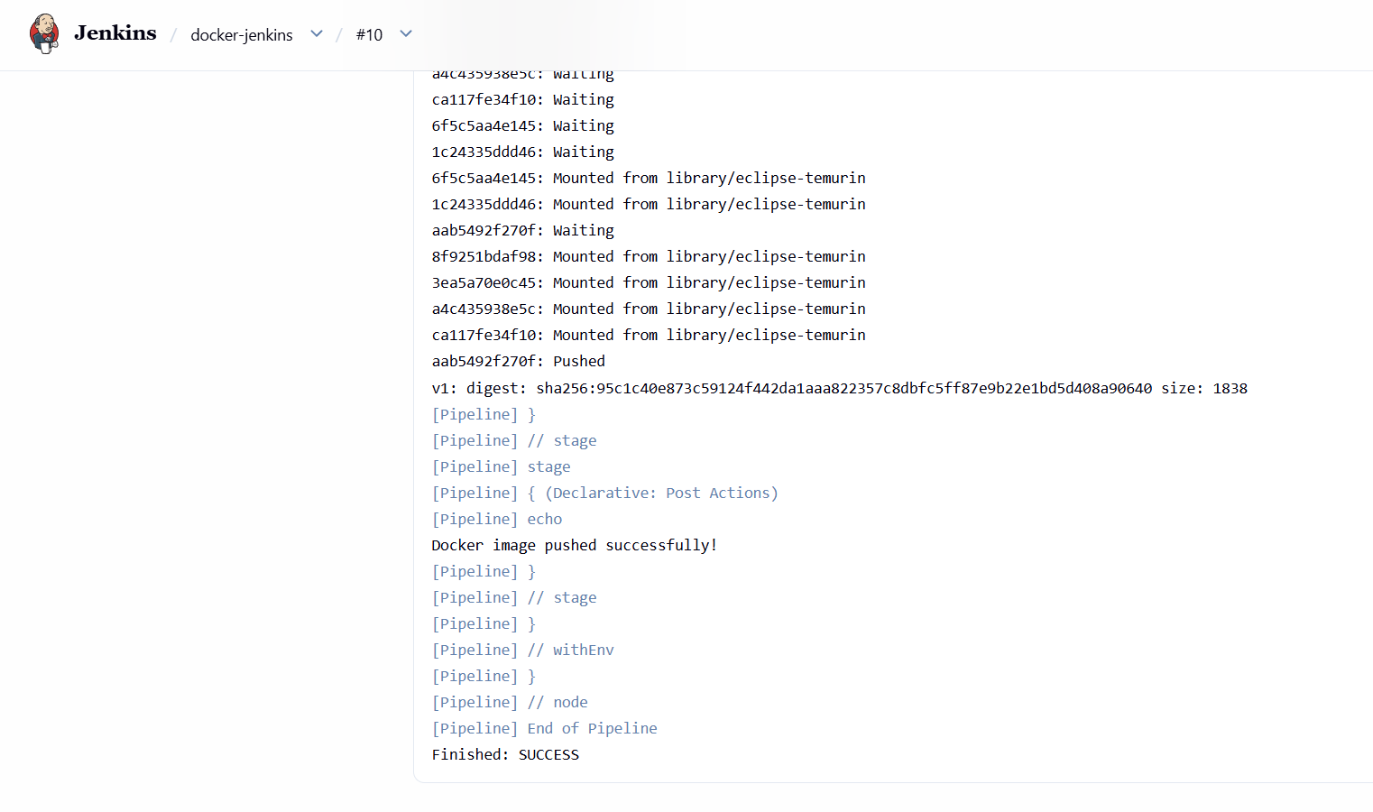
Now lets check in the Dockerhub , Image has successfully pushed , we can check in Image Managemnt in our repo
